**Luther J. List and Dorothy Elizabeth Wolfe List Family**

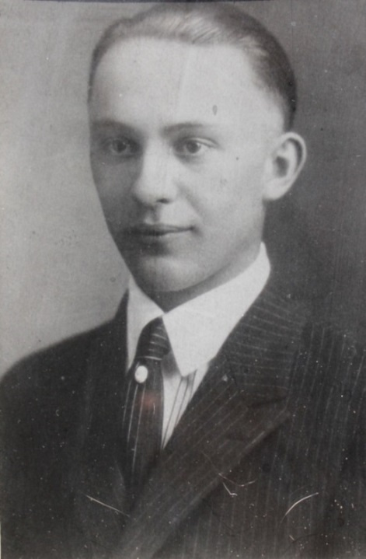

Luther John List – about 1930 (est.)

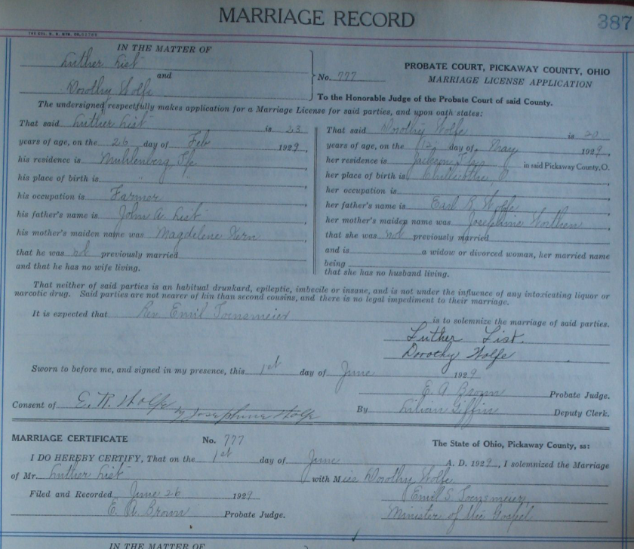

Dorothy Wolfe & Luther List Marriage - 01 Jun 1929